Chapter 13, Problem 79.

Use PSpice to find I₁, I₂, and I₃ in the circuit of Fig. 13.139.

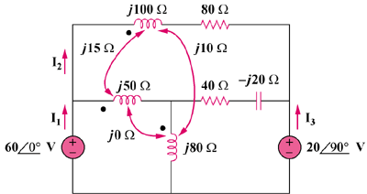

Figure 13.139
For Prob. 13.79.

